**Size quantification and distribution of Polyphosphate-like granules (pPLGs)** **located within *Deinococcus indicus* bacteria**

**Problem Statement**

Quantify the number and size of granules residing within *Deinococcus indicus* bacteria based on EM imaging.

**Methodology**

**Imaging**

To quantify the size and distribution of pPLGs within the bacteria, we used tiling and stitching to cover large field of view with multiple bacteria.

Stitching was done using Fiji Grid/Collection stitching plugin [1].

We then segmented individual bacteria and individual granules residing within them and measured the number of granules and their average and total size within each bacterium.

**Model training**

To segment the bacteria and granules, we used a workflow combining Ilastik [2] pixel classifier followed by further processing using dedicated Fiji [3] macro. We used multiple fields of view from different conditions for training two-stage machine-learning classifier in Ilastik "autocontext" approach to classify pixels into four categories: bacteria, granules, background and unclassified.

**Bacteria, granules identification and quantification**

The trained classifier was applied to the stitched images in Fiji [3]. Bacteria were segmented based on connected component analysis of a filled mask of all pixels classified as bacteria, followed by size (1.6 < size[µm2] < 6]) and shape filtering (circularity > 0.2).

Granules were then segmented based on connected component analysis of a mask of all pixels classified as granules within segmented bacteria and further filtered by size (0.012 < size[µm2] < 0.12]) and shape (circularity > 0.3).

Manual correction was applied to correct the segmentation of some missed or falsely detected bacteria. (Fiji macro: *quantitative_estimation_of_granules_in_bacteria.ijm*)

The size and number of all valid bacteria and granules were extracted and used for further analysis.

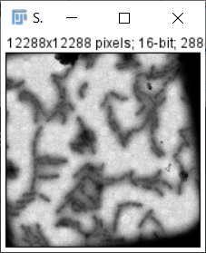 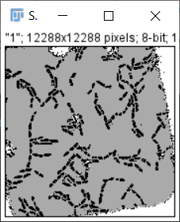 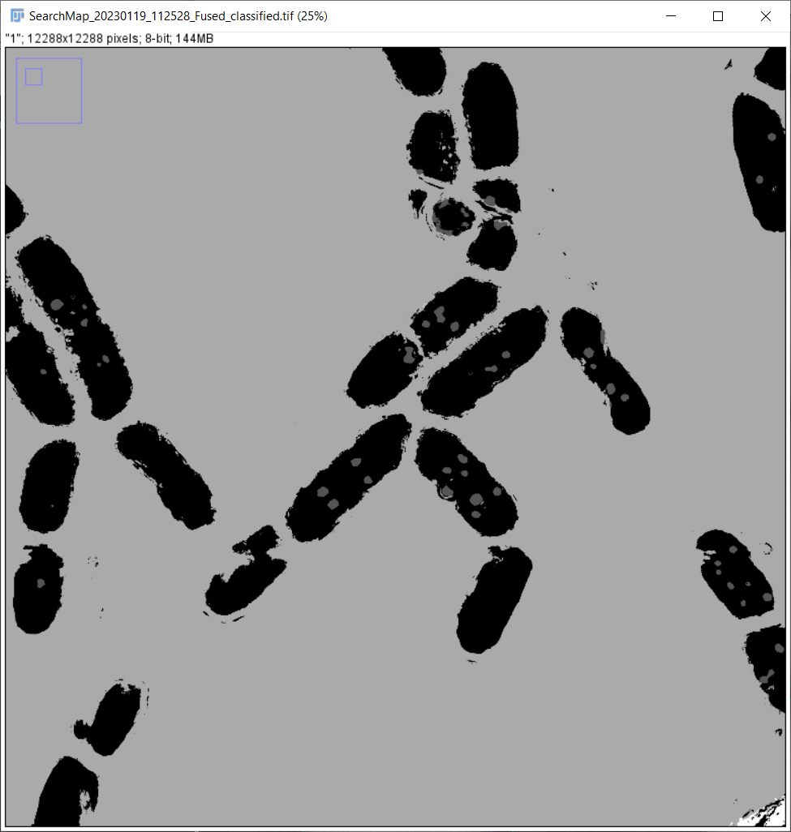

  Original stitched image 🡪 classified image 🡪 zoom in

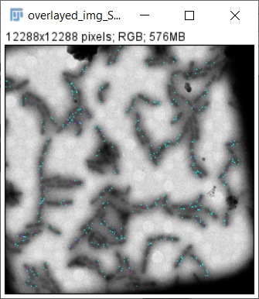 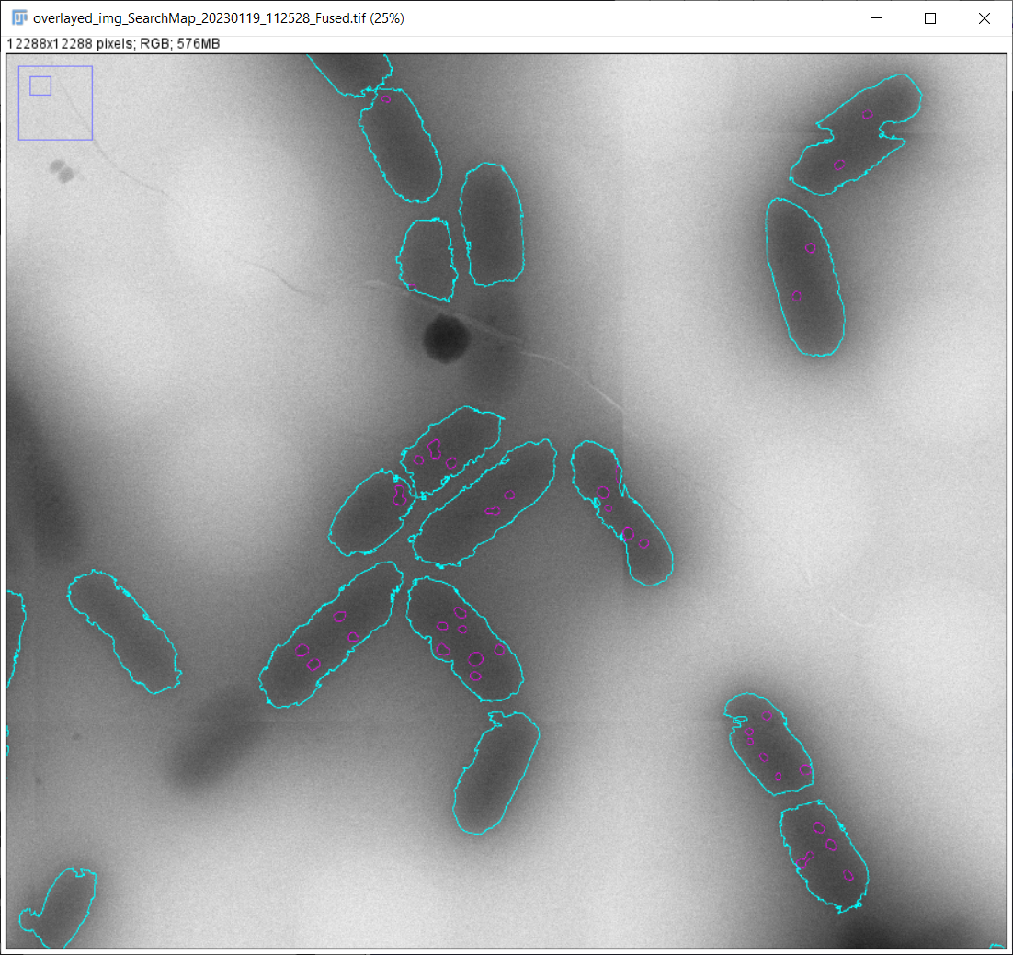

Final overlaid bacteria + granules ROIs 🡪 Zoom in

A note: Undetected/classified bacteria can be manually annotated and added to the ROI manager for further processing in a mode referred to *update mode.*

**Workflow**

1. Open selected image
2. Segment the bacteria and granules
   * Apply **ilastik** *autocontext* classifier to obtain segmentation map model
   * Segment bacteria using thresholding (default) applied to the segmentation map, to output a binary mask followed by hole filling.
   * Filter the masked bacteria ROIs based on size (area) and shape (circularity) metrics to obtain legit bacteria ROIs.
   * Run Roi to label image on the bacteria ROIs to generate bacteria labeled image.
   * Segment the granules using thresholding (default) to the segmentation map, to output binary mask.
   * Filter the masked granules ROIs based on size (area) and shape (circularity) metrics to obtain legit bacteria ROIs. Apply granules-bacteria colocalization analysis by applying (measuring) granules ROIs on bacteria labeled image. This step colocalizes the granules to their respective bacteria.
   * Obtain the area of each granule, the number of granules per bacteria and the average size of the granules per bacteria.

**Output**

The macro saves the following output files (see below for details):

1. Bacteria and granules ROI tables
2. Bacteria and granules result tables
3. Summary table for all image files analyzed
4. The original image with the bacteria and granules ROIs overlays

**Dependencies**

* Fiji: <https://imagej.net/Fiji>
* Ilastik pixel classifier (ilastik-1.4.0rc8) <https://www.ilastik.org/>
* Ilastik Fiji Plugin (we used [ilastik4ij-1.8.2](https://sites.imagej.net/Ilastik/plugins/ilastik4ij-1.8.2.jar-20210407103536).jar which is available in: <https://sites.imagej.net/Ilastik/plugins/>.

**User Guide**

* Run the code, upon which UI will open:

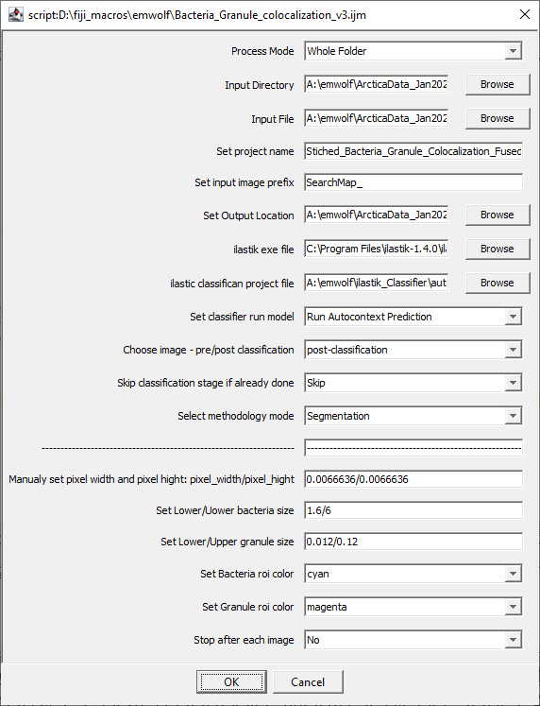

**INPUT**

* Two runs modes are applicable, “directory mode" or “single mode".
  + Directory mode - identifies all the relevant images to be processed and process a file at a time
  + Single mode - a signle file is selected for processing.
* Classification is based on a pretrained ilastik model. The path to the ilastik app and model should be provided
* Several Program-run-modes "degrees of freedom" are provided for processing:
  + Use pre/post classification images
  + redo/skip already classified images,
  + use original or modified bacteria detection
* User provided image units (e.g. [µm/pixel]) and objects (bacteria/granule) thresholds in the same units

**Processing**

* In whole directory mode, a list of the relevant images is generated and the code loops over the images and processes them sequentially
* depending on the selected process option the images are analyzed according to:
  + "Pre-segmentation" / "Post-segmentation" implies whether the image selected has been previously model-based segmented:

"Pre-segmentation" - will run the model on the image and segment (classify) it.

"Post-segmentation" - will load the previously segmented image and continue the process flow based on it.

* + "Redo" / "Skip" implies if to redo the model-based classification even if a classified image exists, when running the "Pre-segmentation":

"Redo" - segments again the images.

"Skip" - skips already segmented images.

* + "Segmentation" / "Update" indicates whether the original model-segmented roiManager is used or a user modified/updated ROIs-roiManager is selected for bacteria/granule processing.

Run-Mode selection logic:

"Pre-segmentation" selection implies "Segmentation" mode;

"Post-segmentation" selection enables selecting between "Segmentation" / "Update".

* **Manuel correction**

The above described process correctly segments most of the bacteria. Additional, manual annotation is supported ny selecting update mode for “Select methodology mode”:

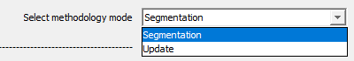

In Update mode the macro skips the segmentation, instead it gets the segmented ROIs from a file, and calculate their updated measurements. The ROIs are read either from manually updated file (naming convention – FN_Fused_Raw_Bacteria_Roi_Update.zip if exist) or otherwise from the original file (FN_Fused_Raw_Bacteria_Roi.zip).

The manual correction is done offline and the update ROI file (uploads into **imageJ**/**Fiji** **roiMnanger**) is appended with the “_Update” suffix (see example above) to distinguish it from the original model-based segmentation/classification.

* **Output**
  + Three tables:
    - Bacteria summary table with data including size, number of granule residing in the bacteria and corresponding mean size. A table per file (*FN__Fused_Granule_Results_Table.txt*).
    - Granule summary table with data corresponding to their estimated size and a "link" to the bacteria they reside in. A table per file (*FN__Fused_Bacteria_Results_Table.txt*).
    - A "Summary Report Table" that stores information for all the files processed. The metrics stored correspond to the number of bacteria and granule after segmentation and following filtering (*FN_ Summary_Report_Table.txt*).

Additionally, it includes a flag indicating whether the image processed resulted in detected bacteria or granule, or no bacteria/granule where detected.

* + Two ROI files (imagej/Fiji roiManager tables):
    - ROIs corresponding to the bacteria and granules

(*FN_Bacteria_Roi.zip, FN_Granule_In_Bacteria_Roi.zip*, respectively).

* + Two images:
    - Model-segmented image (*FN_classified.tif*)
    - Raw image overplayed with bacteria + granule ROIs (*overlayed_img_FN.tif*).

**References**

[1] Preibisch S, Saalfeld S, Tomancak P. Globally optimal stitching of tiled 3D microscopic image acquisitions. Bioinformatics. 2009 Jun 1;25(11):1463-5. doi: 10.1093/bioinformatics/btp184. Epub 2009 Apr 3. PMID: 19346324; PMCID: PMC2682522.

[2] Stuart Berg, Dominik Kutra, Thorben Kroeger, Christoph N. Straehle, Bernhard X. Kausler, Carsten Haubold, Martin Schiegg, Janez Ales, Thorsten Beier, Markus Rudy, Kemal Eren, Jaime I Cervantes, Buote Xu, Fynn Beuttenmueller, Adrian Wolny, Chong Zhang, Ullrich Koethe, Fred A. Hamprecht & Anna Kreshuk.  ilastik: interactive machine learning for (bio)image analysis. Nat Methods 16, 1226–1232 (2019). <https://doi.org/10.1038/s41592-019-0582-9>

[3] Schindelin, J., Arganda-Carreras, I., Frise, E., Kaynig, V., Longair, M., Pietzsch, T., … Cardona, A. (2012). Fiji: an open-source platform for biological-image analysis. Nature Methods, 9(7), 676–682. [doi:10.1038/nmeth.2019](https://doi.org/10.1038/nmeth.2019)